Name: _______________________________ Date: _____________
Period: ____ Earth Science

Lab: Evidence to Support Continental Drift

Introduction
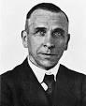
Alfred Wegener was a German climatologist who noticed that the continents of the world seem to fit together like a giant jigsaw puzzle. He proposed that at one point in time all the continents were together as one super continent that he named Pangaea. His theory of continental drift was laughed at by the scientific community. He searched the world for other stronger evidence that would help support his theory. He died in 1930 on an expedition in Greenland. At the time of his death his theory was winning more acceptance, but it was not until the 1950’s that his work was acknowledged and appreciated.

Learning Target
After 42 minutes, I can identify evidence to support Alfred Wegner’s theory and describe how that evidence infers that the continents have moved throughout history.

Tasks:
- Working with your partner, you will have 3 minutes at each station to identify evidence that supports Alfred Wegener’s theory of Continental Drift (pages 2 & 3 of this lab).
- Use your acquired evidence to construct the super continent, Pangea.
- In complete sentences, answer the discussion questions to explain your understanding of the theory of continental drift.

Task 1:
Working with your partner, you will have 3 minutes at each station to identify evidence that supports Alfred Wegener’s theory of Continental Drift (pages 2 & 3 of this lab).

Station 1: Fossil Evidence

Describe what the image is showing you.
______________________________________________________________________________
______________________________________________________________________________

______________________________________________________________________________

Explain how the evidence supports continental drift.
______________________________________________________________________________
______________________________________________________________________________

______________________________________________________________________________

Station 2: Rock and Mountain Evidence

The darker regions represent mountains which contain rocks of similar age and composition. Describe what the image is showing you.
______________________________________________________________________________

______________________________________________________________________________

______________________________________________________________________________

Explain how the evidence supports continental drift.
______________________________________________________________________________
______________________________________________________________________________

______________________________________________________________________________

Station 3: Climate Evidence - Glacial Evidence

Please describe what the image is showing you.
______________________________________________________________________________

______________________________________________________________________________

______________________________________________________________________________

Explain how the evidence supports continental drift.
______________________________________________________________________________

______________________________________________________________________________

______________________________________________________________________________

Station 4: Climate Evidence - Coal Deposits

Coal is formed from the remains of plants that died long ago in and around tropical swampy areas. Living corals are found in warm, shallow seas. Describe what the image is showing you.
______________________________________________________________________________

______________________________________________________________________________

______________________________________________________________________________

Explain how the evidence supports continental drift.
______________________________________________________________________________

______________________________________________________________________________

______________________________________________________________________________

Task 2:
Use your acquired evidence to construct the super continent, Pangea.

On the American Museum of Natural History – A Plate Tectonics Puzzle worksheet, construct Pangea by gluing down the landmasses you cut out.

Be sure to:
- Work together with your partner.
- Use the evidence from the previous task and the evidence on each landmass to be as accurate as possible.
- Make sure both you and your lab partner’s name are on the completed Pangea worksheet.

Task 3:
In complete sentences, answer the discussion questions to explain your understanding of the theory of continental drift.

Discussion Questions (answer in complete sentences):

1. Which piece of evidence provides the greatest support for the hypothesis that the eastern coast of North America was once joined with the western coast of Europe?

2. How do you think Wegener’s background as a climatologist contributed to his hypothesis that the continents were once joined?

3. Explain how the presence of large coal deposits in Pennsylvania and West Virginia can be used as evidence to support the inferred latitude of North America in the past.

4. Identify the 3 types of evidence that supports Africa and South America were once adjoining.

Using ESRT page 9 [Inferred Positions of Earth’s Landmasses], answer the following questions:

5. Indicate the direction each landmass drifted from 359 million years ago to present (N, NW, E, etc.)

Africa: _________ Europe/Asia (Eurasia): _________ North America: _________

India: _________ South America: _________ Australia: _________

Antarctica: _________

6. Explain how the latitude and climate of North America has changed over the past 359 million years.

7. Mountain-building events are called orogenies. Looking at ESRT page 9 [Important Geologic Events in New York], what caused the Alleghenian orogeny and what did that form? Hint: Look for the mountain symbols.

8. Pangea began to break up approximately how many millions of years ago? (ESRT page 9 [Important Geologic Events in New York]).

9. The picture below represents the mechanism that is theorized to move the continents. Examine the photograph and explain how you think the mechanism works to move the continents.
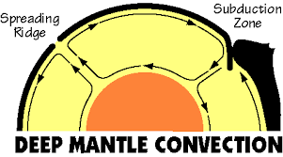

Fossil Evidence

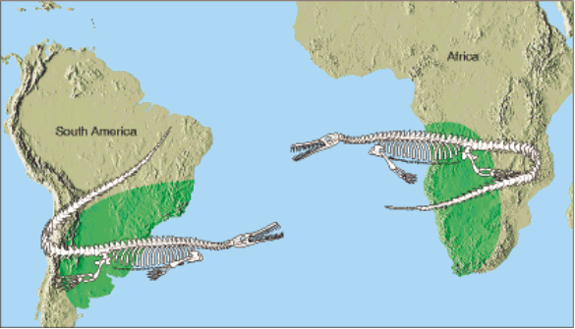

The green shaded area represents the only locations on Earth where the fossil remains of Mesosaurus have been found. Mesosaurus was a large reptile that lived in fresh water.

Rock Evidence

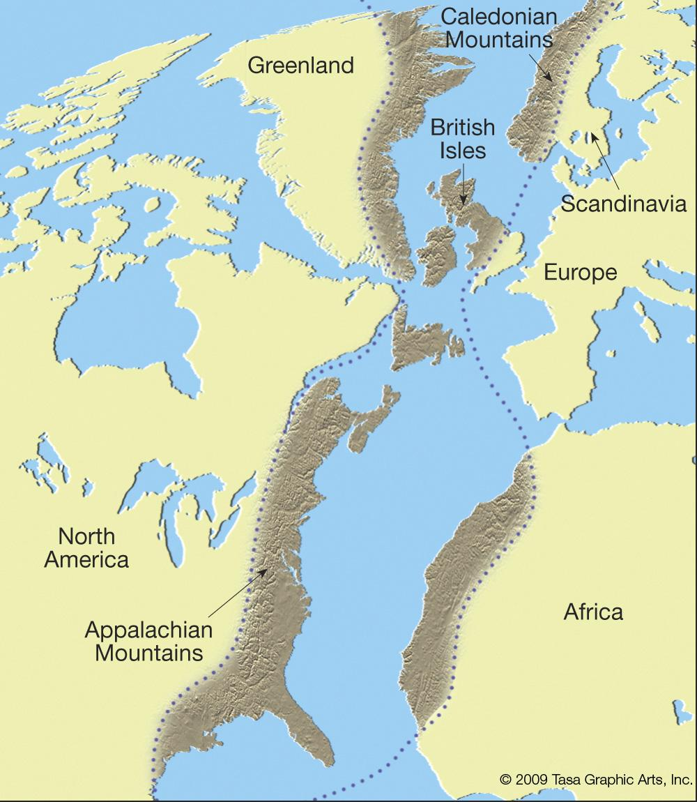

Climate Evidence: Glacial Deposits

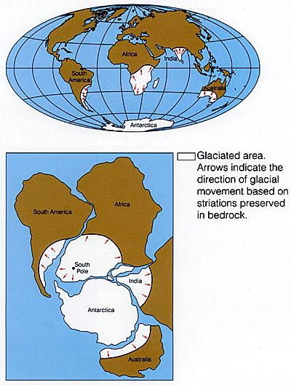

Climate Evidence: Coal Deposits

